Project Design Phase
Solution Architecture

Date | 15 February 2026
Team ID | LTVIP2026TMIDS87294
Project Name | ResolveNow: Your platform for online complaints
Maximum Marks | 4 Marks

Solution Architecture Diagram:
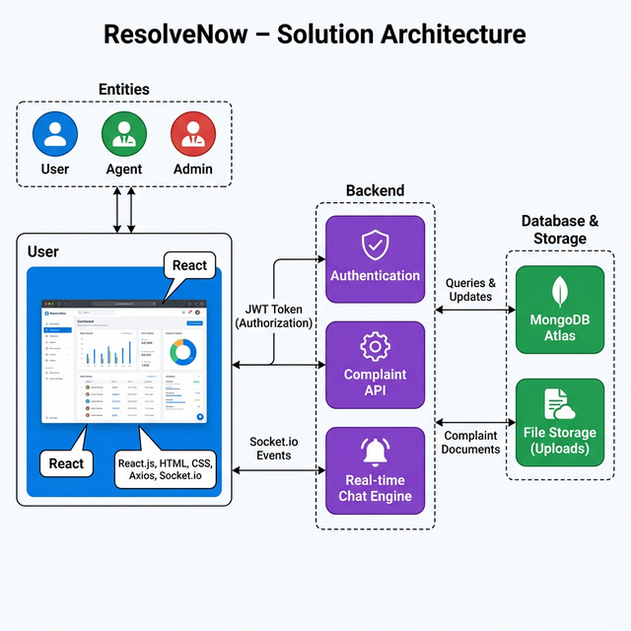
Figure 1: Architecture and data flow of the ResolveNow: Your platform for online complaints

